3A. ADDRESS ASSIGNMENT
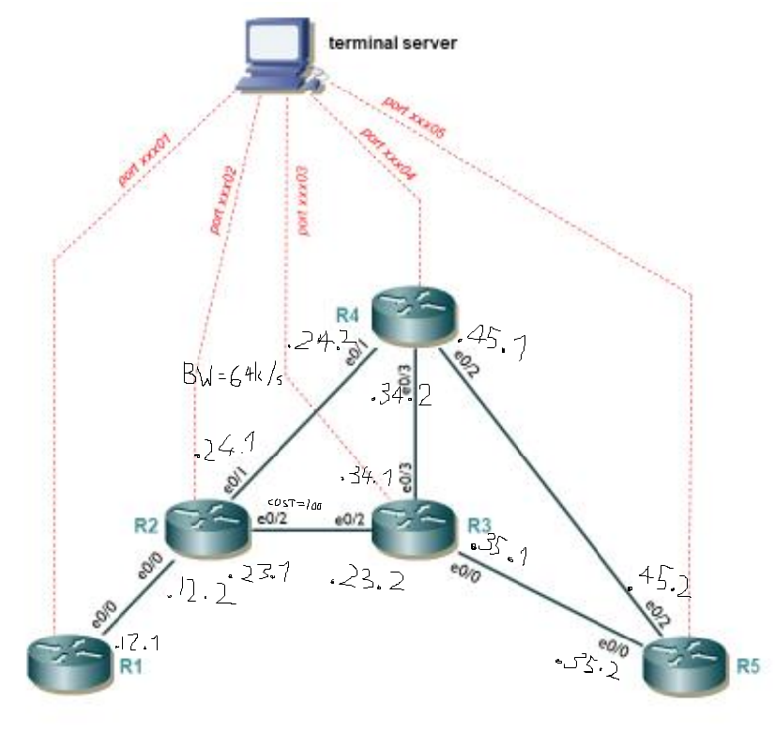
[TODO: Paste adress scheme image here and explain]

3B. RUNNING OSPF
[TODO: Setup p2p ospf and do the other shit for part B, then traceroute R1->R5 and explain the how the cost diff for R2->R3 affects this!!!]

3C. BASIC MPLS CONFIGURATION
[TODO: Setup MPLS]

3D. VERIFY MPLS/LDP SETUP
[TODO: explain MPLS forwarding tables?]

3E. CHECK PATHS
[TODO: ]

3F. CONFIGURE BASIC TRAFFIC ENGINEERING
[]

